**CODE#1**

**#include<iostream>**

**using namespace std;**

**class employee**

**{**

**private:**

**int count;**

**int count1;**

**int total;**

**int HR,FR;**

**public:**

**employee():count(0),count1(0)**

**{**

**}**

**void operator++()**

**{**

**cout<<"\nEMPLOYEE IS HIRED"<<endl;**

**++count;**

**HR=count;**

**}**

**void operator--()**

**{**

**cout<<"\nEMPLOYEE IS FIRED"<<endl;**

**--count1;**

**FR=count1;**

**}**

**void display_data()**

**{**

**FR=(-1*FR);**

**total=HR+FR;**

**cout<<"\ntotal employees applied :"<<total<<endl;**

**cout<<"\nHIRED employees :"<<HR<<endl;**

**cout<<"\nFIRED employees :"<<FR<<endl;**

**}**

**};**

**int main()**

**{**

**int n;**

**char check='y';**

**employee e1;**

**while(check=='Y'||check=='y')**

**{**

**cout<<"PRESS 1 IF YOU WANT TO HIRED AN EMPLOYEE:"<<endl;**

**cout<<"PRESS 2 IF YOU WANT TO FIRED AN EMPLOYEE:"<<endl;**

**cin>>n;**

**if(n==1)**

**{**

**++e1;**

**}**

**else if(n==2)**

**{**

**--e1;**

**}**

**cout<<"\n(Y/N) DO YOU WANT TO HIRED OR FIRED ANY OTHER EMPLOYEE:"<<endl;**

**cin>>check;**

**}**

**e1.display_data();**

**return 0;**

**}**

**OUTPUT:-**

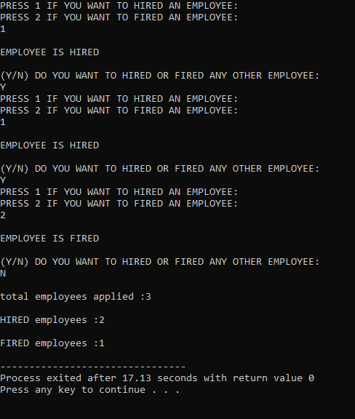

**CODE#2**

**#include<iostream>**

**using namespace std;**

**class company_stock**

**{**

**protected:**

**int stock_size;**

**float stock_price;**

**public:**

**company_stock(int s, float p):stock_size(s), stock_price(p)**

**{}**

**void calculatePrice() {**

**float totalPrice =stock_size*stock_price;**

**cout<<"Total price:"<<totalPrice<<"RS"<< endl;**

**}**

**};**

**class PMP:public company_stock**

**{**

**public:**

**PMP(int s,float p):company_stock(s,p)**

**{}**

**void dividend()**

**{**

**float dividend=stock_size*50/4;**

**cout<<"\nQUARTELY DIVIDEND of 50 RUPEES PER SHARE FOR PMP : "<<dividend<<"RS"<< endl;**

**}**

**};**

**class KPC:public company_stock**

**{**

**public:**

**KPC(int s , float p ):company_stock(s,p)**

**{}**

**void additionalshares()**

**{**

**float bundle=stock_size/100;**

**float additional_shares=bundle*5;**

**cout<<"\nAN ADDITIONAL BUNDLE OF SHARES FOR KPC ARE:"<<additional_shares<<endl;**

**additional_shares=stock_size + additional_shares;**

**cout<<"TOTAL SIZE OF STOCK SHARES AFTER ADDITONAL SHARES:"<<additional_shares<<endl;**

**}**

**};**

**class HCR:public company_stock**

**{**

**public:**

**HCR(int s,float p):company_stock(s,p)**

**{}**

**void noshares()**

**{**

**cout<<"\nNO EXTRA SHARES OR DIVIDEND FOR HCR:"<<endl;**

**}**

**};**

**int main()**

**{**

**PMP p(100,433);**

**KPC k(300,22.08);**

**HCR h(100,94.98);**

**cout<<" _____________________________________"<<endl;**

**cout<<"| |"<<endl;**

**cout<<"| |"<<endl;**

**cout<<"| PMP |"<<endl;**

**cout<<"| |"<<endl;**

**cout<<"|_____________________________________|"<<endl;**

**p.dividend();**

**p.calculatePrice();**

**cout<<" _____________________________________"<<endl;**

**cout<<"| |"<<endl;**

**cout<<"| |"<<endl;**

**cout<<"| KPC |"<<endl;**

**cout<<"| |"<<endl;**

**cout<<"|_____________________________________|"<<endl;**

**k.additionalshares();**

**k.calculatePrice();**

**cout<<" _____________________________________"<<endl;**

**cout<<"| |"<<endl;**

**cout<<"| |"<<endl;**

**cout<<"| HRC |"<<endl;**

**cout<<"| |"<<endl;**

**cout<<"|_____________________________________|"<<endl;**

**h.noshares();**

**h.calculatePrice();**

**}**

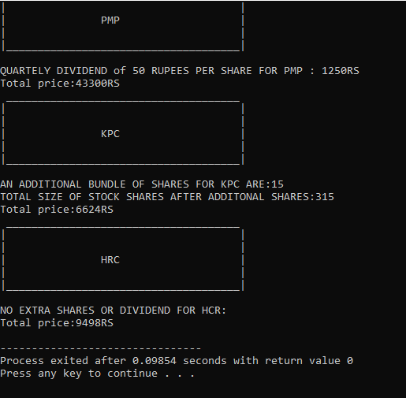**OUTPUT:-**

**CODE#3**

**#include<iostream>**

**using namespace std;**

**class publications**

**{**

**private:**

**string title;**

**int price;**

**public:**

**publications():title("-"), price(0)**

**{}**

**void getdata()**

**{**

**cout<<"enter tilte:"<<endl;**

**cin>>title;**

**cout<<"enter price:"<<endl;**

**cin>>price;**

**}**

**void showdata()**

**{**

**cout<<"title :"<<title<<endl;**

**cout<<"the price RS:"<<price<<endl;**

**}**

**};**

**class book:public publications**

**{**

**private:**

**string ISBN_no;**

**public:**

**book():ISBN_no("")**

**{}**

**book(string i):ISBN_no(i)**

**{**

**publications::getdata();**

**}**

**void getdata()**

**{**

**publications::getdata();**

**cout<<"enter ISBN_no:"<<endl;**

**cin>>ISBN_no;**

**}**

**void showdata()**

**{**

**cout<<ISBN_no<<endl;**

**publications::showdata();**

**}**

**};**

**class Magazine:public publications**

**{**

**private:**

**int pages;**

**int edition;**

**public:**

**Magazine ():pages(0),edition(0)**

**{}**

**Magazine (int pg , int e ):pages(pg),edition(e)**

**{**

**publications::getdata();**

**}**

**void getdata()**

**{**

**publications::getdata();**

**cout<<"enter page_no:"<<endl;**

**cin>>pages;**

**cout<<"enter edition:"<<endl;**

**cin>>edition;**

**}**

**void showdata()**

**{**

**cout<<"\nTotal pages:"<<pages<<endl;**

**cout<<"Eidtion:"<<edition<<"th"<<endl;**

**publications::showdata();**

**}**

**};**

**class dvd:public publications**

**{**

**private:**

**int capacity;**

**public:**

**dvd(): capacity(0)**

**{}**

**dvd(int c): capacity(c)**

**{**

**publications::getdata();**

**}**

**void getdata()**

**{**

**publications::getdata();**

**cout<<"enter capacity:"<<endl;**

**cin>>capacity;**

**}**

**void showdata()**

**{**

**cout<<"\nThe capacitiy of DVD:"<<capacity<<"GB"<<endl;**

**publications::showdata();**

**}**

**};**

**int main()**

**{**

**cout<<" _____________________________________"<<endl;**

**cout<<"| |"<<endl;**

**cout<<"| |"<<endl;**

**cout<<"| BOOK |"<<endl;**

**cout<<"| |"<<endl;**

**cout<<"|_____________________________________|"<<endl;**

**book b("978-2345-05-123-4"),b1;**

**b1.getdata();**

**cout<<"\nbook1 detail:"<<endl;**

**b1.showdata();**

**cout<<"\nbook2 detail:"<<endl;**

**b.showdata();**

**cout<<" _____________________________________"<<endl;**

**cout<<"| |"<<endl;**

**cout<<"| |"<<endl;**

**cout<<"| MAGAZINE |"<<endl;**

**cout<<"| |"<<endl;**

**cout<<"|_____________________________________|"<<endl;**

**Magazine m(500,7),m1;**

**m1.getdata();**

**cout<<"\nMagazine1 detail:"<<endl;**

**m1.showdata();**

**cout<<"\nMagazine2 detail:"<<endl;**

**m.showdata();**

**cout<<" _____________________________________"<<endl;**

**cout<<"| |"<<endl;**

**cout<<"| |"<<endl;**

**cout<<"| DVD |"<<endl;**

**cout<<"| |"<<endl;**

**cout<<"|_____________________________________|"<<endl;**

**dvd d(1),d1;**

**d1.getdata();**

**cout<<"\ndvd1 detail:"<<endl;**

**d1.showdata();**

**cout<<"\ndvd2 detail:"<<endl;**

**d.showdata();**

**}**

**OUTPUT:-**

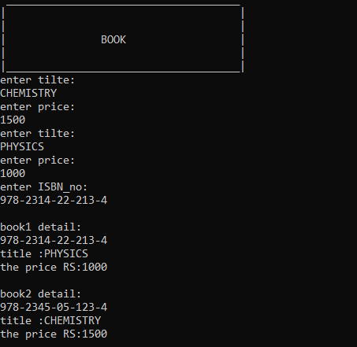

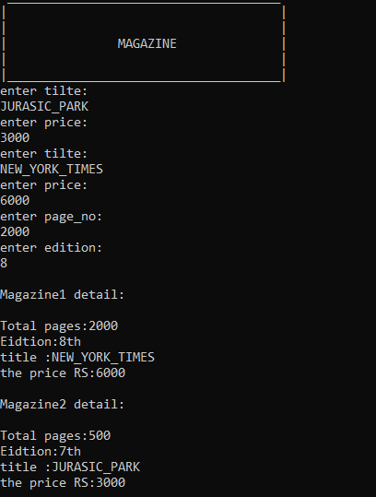

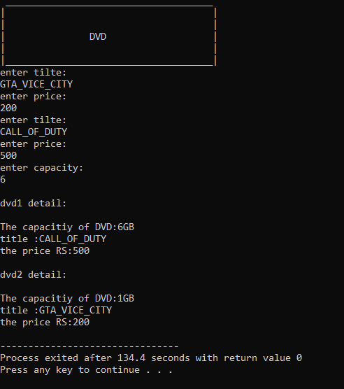

**CODE#4**

**#include<iostream>**

**using namespace std;**

**class bill**

**{**

**protected:**

**float tax;**

**int units;**

**public:**

**void getdata()**

**{**

**cout<<"ENTER THE UNITS CONSUMED:"<<endl;**

**cin>>units;**

**cout<<"ENTER THE TAX:"<<endl;**

**cin>>tax;**

**}**

**void showdata()**

**{**

**cout<<"\nUNITS CONSUMED: "<<units<<"UNITS"<<endl;**

**cout<<"TAX YOU HAVE TO PAY: "<<tax<<"%"<<endl;**

**}**

**};**

**class Electric_bill:public bill**

**{**

**private:**

**float final_amount;**

**int charges;**

**public:**

**calcbill()**

**{**

**if(units>=100 && units<200)**

**{**

**charges=units*1;**

**}**

**else if(units>=200 && units<300)**

**{**

**charges=units*2;**

**}**

**else if(units>=300 && units<500)**

**{**

**charges=units*3;**

**}**

**else if(units==500)**

**{**

**charges=units*4;**

**}**

**else if(units>500)**

**{**

**charges=units*5;**

**}**

**else**

**{**

**cout<<"invalid"<<endl;**

**}**

**final_amount = charges + tax/100 + 500;**

**cout<<" __________________________________________________________________________________"<<endl;**

**cout<<"| K-ELECTRIC BILL |"<<endl;**

**cout<<"| |"<<endl;**

**cout<<"| |"<<endl;**

**cout<<"|YOUR CHARGES ARE: "<<charges<<"RS FOR "<<units<<"UNITS |"<<endl;**

**cout<<"| |"<<endl;**

**cout<<"| |"<<endl;**

**cout<<"| |"<<endl;**

**cout<<"| |"<<endl;**

**cout<<"|YOUR TOTAL BILL WITH: "<<tax<<"% TAX & 500 METER RENT IS: |"<<endl;**

**cout<<"|BILL:- "<<final_amount<<"RS |"<<endl;**

**cout<<"| |"<<endl;**

**cout<<"| |"<<endl;**

**cout<<"| |"<<endl;**

**cout<<"|__________________________________________________________________________________|"<<endl;**

**}**

**};**

**int main()**

**{**

**Electric_bill e;**

**e.getdata();**

**e.showdata();**

**e.calcbill();**

**return 0;**

**}**

**OUTPUT:-**

